OS Process, Debug, and Test Action Sampler

**Steps 1.11.1:** Creatingan OS process in JMeter

* Open JMeter.
* Right click on Test Plan.
* Click on Thread(Users)->Thread Group.

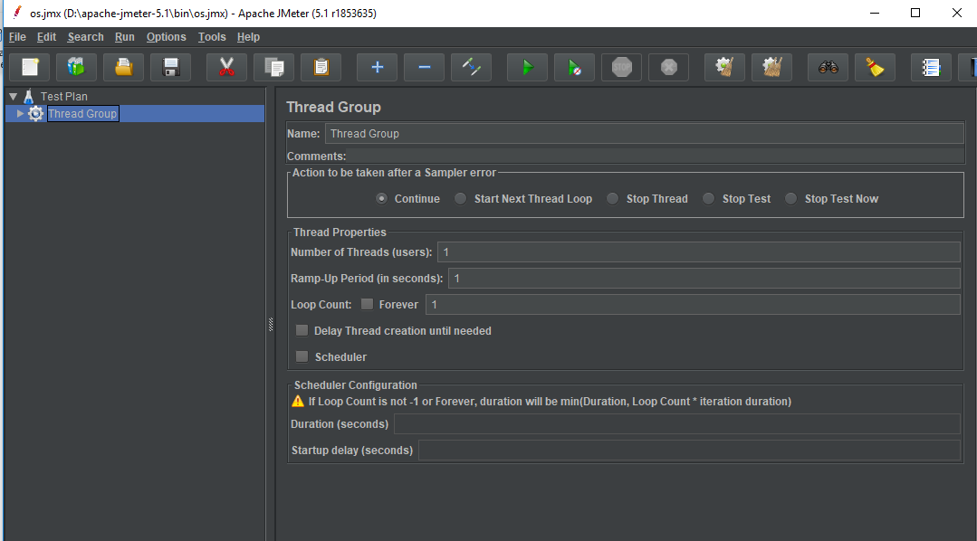

* Right click on the thread group.
* Go to Add -> Sampler -> OS process sampler.

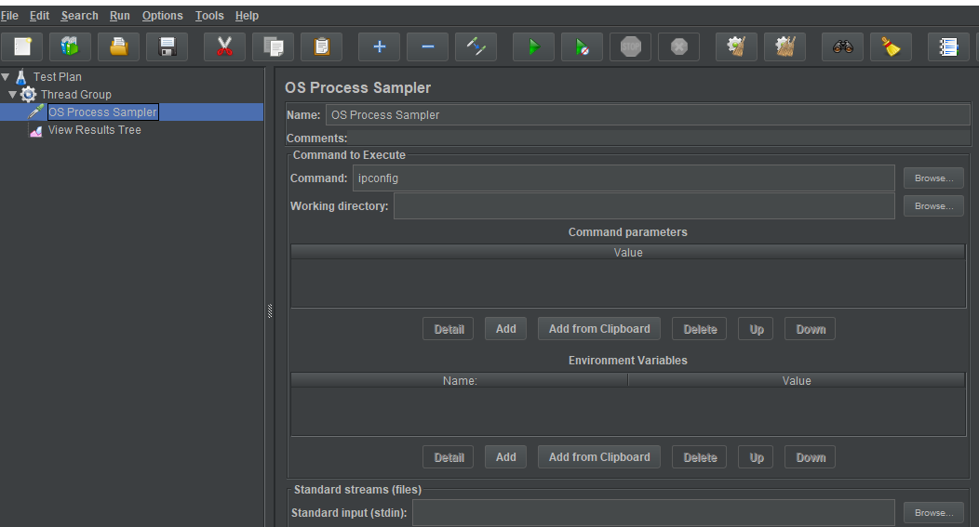

* Right click on the thread group.
* Go to Add -> Listener -> View results tree.

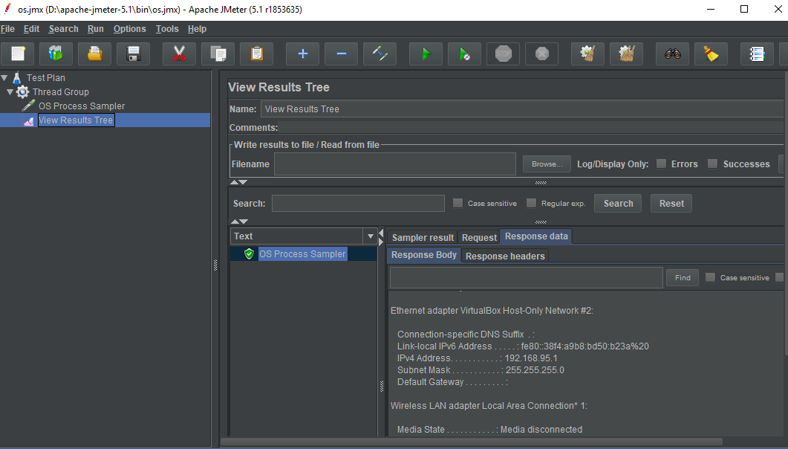

* Run the result tree.



**Steps 1.11.2:** Debugging in JMeter and testing the action sampler

* Right click on Test Plan.
* Click on Thread(Users) -> Thread Group.
* Right click on thread group -> Add -> samplers -> HTTP Request -> Enter Server name ‘lifecharger.org.’

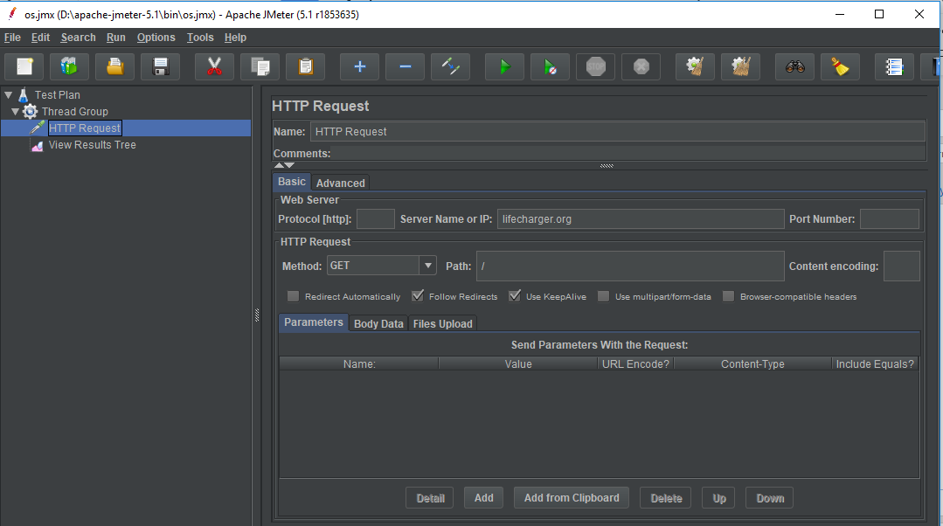

* Run the result tree.

